HEALTH DIRECT GUIDE FOR CLINICIANS

To access Health Direct please ensure webpage is opened using Google Chrome

OPTION 1
- Open the Bendigo Health Website www.bendigoheatlth.org.au
- Click on Telehealth (found on front page)
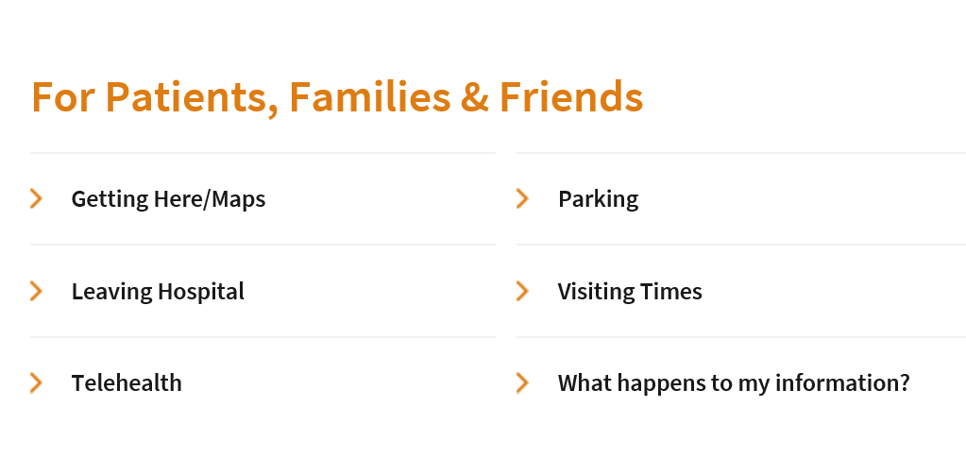
- Scroll down and click on Staff Login

OPTION 2
- Open webpage vcc.healthdirect.org.au/login using GOOGLE CHROME

Health Direct Login
Sign in with email address and password (access supplied by department admin or IT)
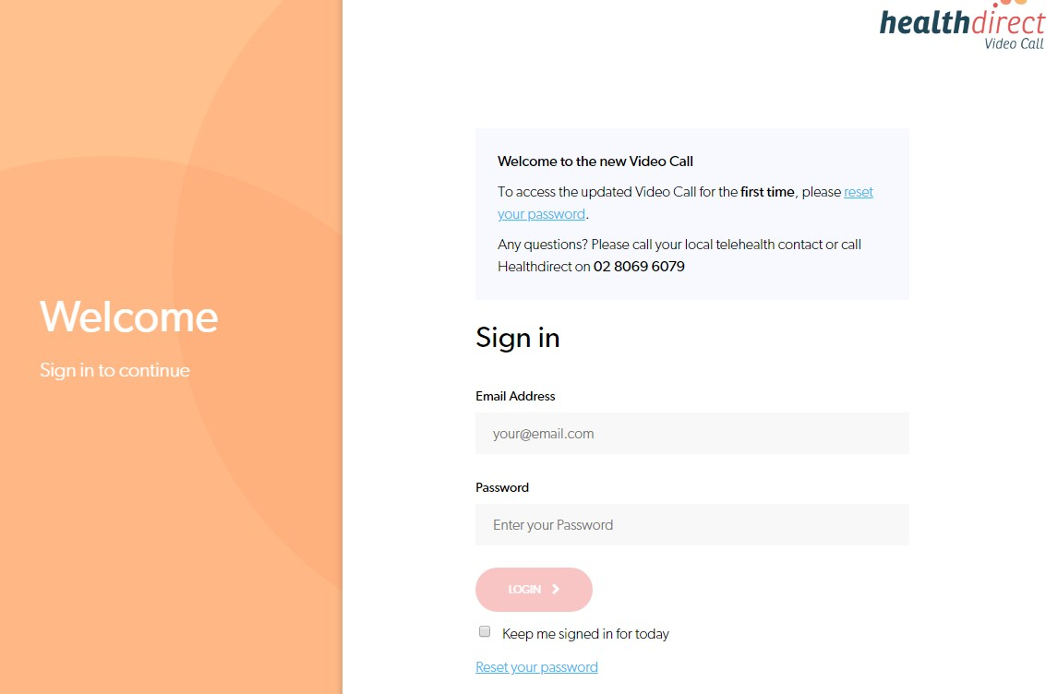

- Your login details will take you to the relevant waiting area.
- Patients waiting, will be displayed as below.

WE SUGGEST COMPLETING THE PRE-CALL TEST, PRIOR TO EACH CLINIC OR CONSULTATION TO ENSURE A SUCCESFULL & EFFICIENT CONNECTION. INSTRUCTIONS FOR THIS CAN BE FOUND ON PAGE 3.
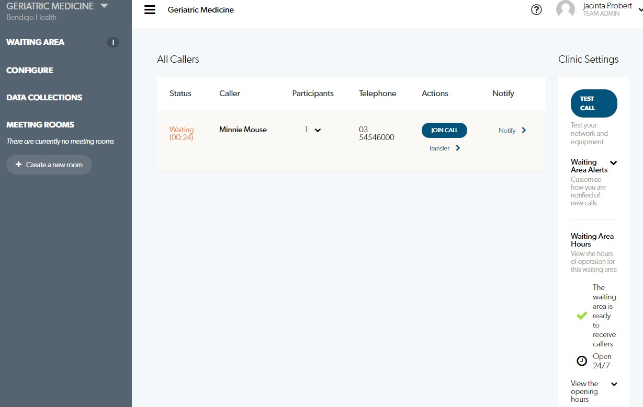

- Check the patient names in the waiting room
- Select “Join Call” next to the appropriate patient to connect the video call.
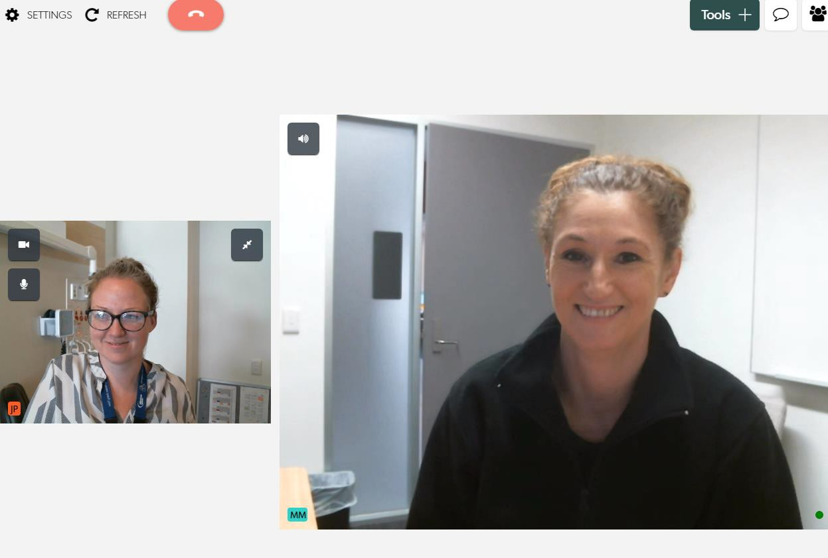

- Once video call is complete, select “End”

NB: If you are allocated to multiple waiting areas, you can select which waiting area you wish to connect with via the top left hand side drop down box.
The area you are currently in, is displayed in the top left hand corner.
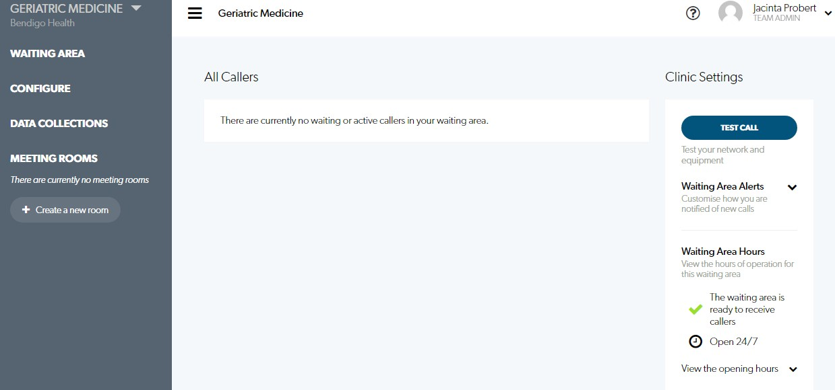

- NB: If you are having difficulty with your connection, please run a test call as below.
- Select “TEST CALL” from the left side information panel.

WE SUGGEST COMPLETING THE PRE-CALL TEST, PRIOR TO EACH CLINIC OR CONSULTATION TO ENSURE A SUCCESSFUL AND EFFICIENT CONNECTION.

  - The Pre-call test will test your microphone, sound, internet connection bandwidth and video quality.
  - Select “Start test”
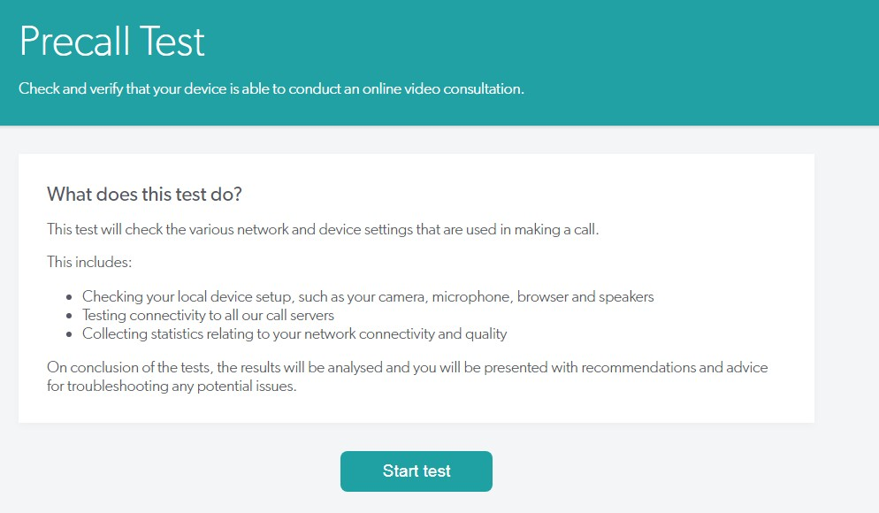

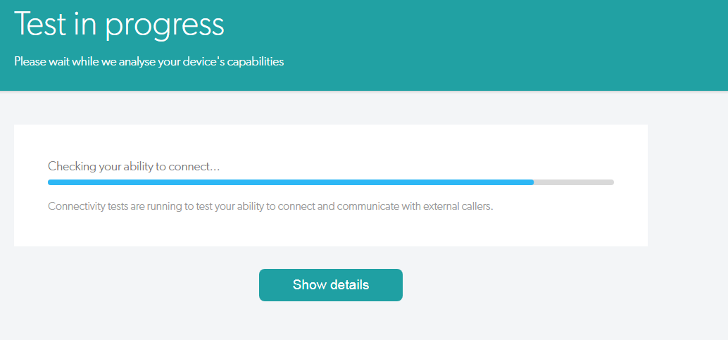
    - Pre-call test results will be displayed as below.
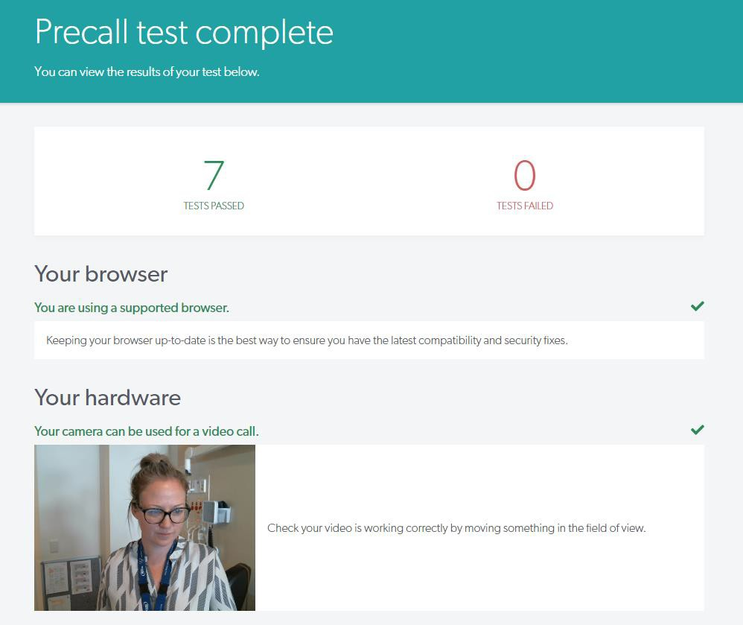

    - If one of these tests fails, the pre-call test will advise you of what is insufficient to complete the video call & offer suggestion as to how this can be rectified. If the failure, cannot be rectified, please contact IT Support Services on 5454 8470.
